Block 2 Challenge Proposal

1. Purpose: To create an app where a user can write, save, edit, and delete notes.
2. Audience: General audience - 8 years old and above
3. Data Source: Local storage
4. Module: note class, functions to addNote, editNote, deleteNote, notes array
5. Wireframe, Colors: An idea for the wireframe and colors is below. I figured that a default white and gray would work with anyone.

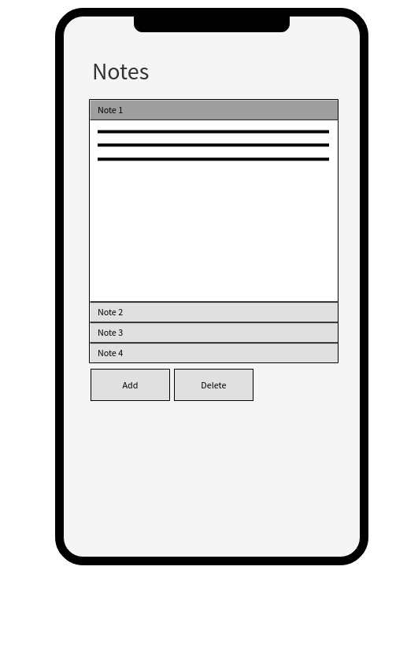

1. Schedule:

Week 10 (5-7 hours) – revise proposal or idea if necessary. Look for examples of notes app and figure out if there are other elements or features that I would like to add.

Week 11 (5-7 hours) – start with the HTML and CSS code. Research online on how to make things work as necessary.

Week 12 (5-7 hours) – start working on the JavaScript code. Research online on how to make things work as necessary. Aim to finish the HTML and CSS codes between this week and next week.

Week 13 (5-7 hours) – Aim to finish the JavaScript code by this week. Test and debug as necessary. Compile everything for completion for next week.

Week 14 (2-5 hours) – Finalize project and submit.